Voter Login Pseudocode
Page1 (Login):
INPUT firstname
INPUT lastname
INPUT dateOfBirth
INPUT last4SSN or INPUT DLN

ON Click "Sign In" button:
CALL ValidateVoterInfoReturnVoterId(firstname, lastname, dateOfBirth, last4SSN, DLN)(plugin)
RETURNS voterId, isConfidential, isValid

IF isConfidential = true THEN
DISPLAY "Your records are sealed." in red
ELSE
IF isValid = true THEN
STORE voterId in session
REDIRECT to Page2
ELSE
DISPLAY "Invalid information. Please try again."
ENDIF
ENDIF
Page2:
ON Page2 Load:
RETRIEVE voterId from session
CALL voterInfo = GetVoterRecord(voterId)
DISPLAY voterInfo under "My Information"
CALL currentEarlyBallotElections = GetEarlyBallotElections() (plugin)
CALL myElections = GetOnlineElectionInfo(voterId) (plugin)
IF myElections has one or more rows THEN
FOR EACH electionRow IN myElections:
FOR EACH earlyBallotElection IN currentEarlyBallotElections:
IF electionRow["ELECTION_NO"] == earlyBallotElection.Number THEN
IF current date <= earlyBallotEnd THEN
CREATE a "Request" button
ON click → REDIRECT to "Request Ballot" page
ELSE
DISPLAY "Online Ballot Request is not available after {earlyBallotEnd}" in bold
ENDIF
ENDIF
ENDFOR
ENDFOR
ELSE
DISPLAY "You are ineligible."
ENDIF
Sign Out:
ON Click "Sign Out" button:
DELETE session variables (voterId, firstname, lastname)
REDIRECT to Page1

Page 1
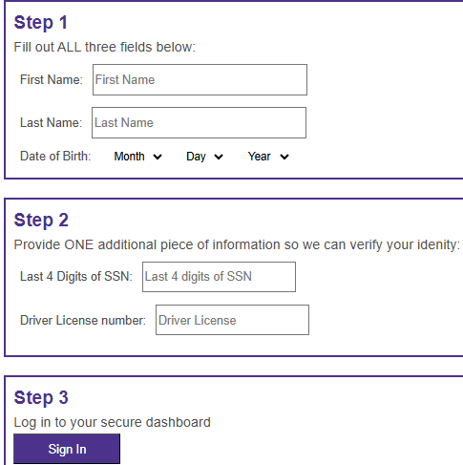

Page 2
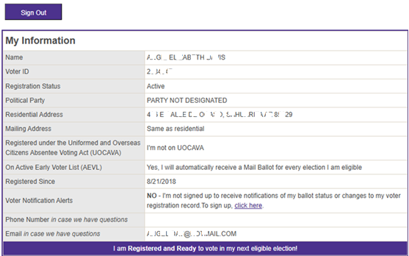

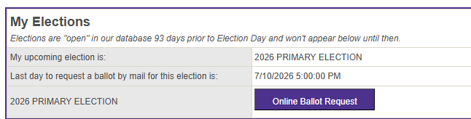

******************************************************************************************-
Notes: ValidateVoterInfoReturnVoterId, GetEarlyBallotElections and GetOnlineElectionInfo(voterId) are plugins. ValidateVoterInfoReturnVoterId is already completed. I will work on developing the two remaining plugins next."

